To be able to access mockups

1. Go to [https://epam.invisionapp.com](https://epam.invisionapp.com/)
2. Sign in using SSO. This will create user account.

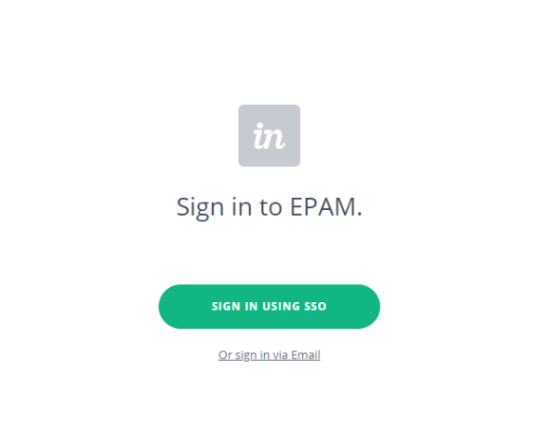

1. Select Developer

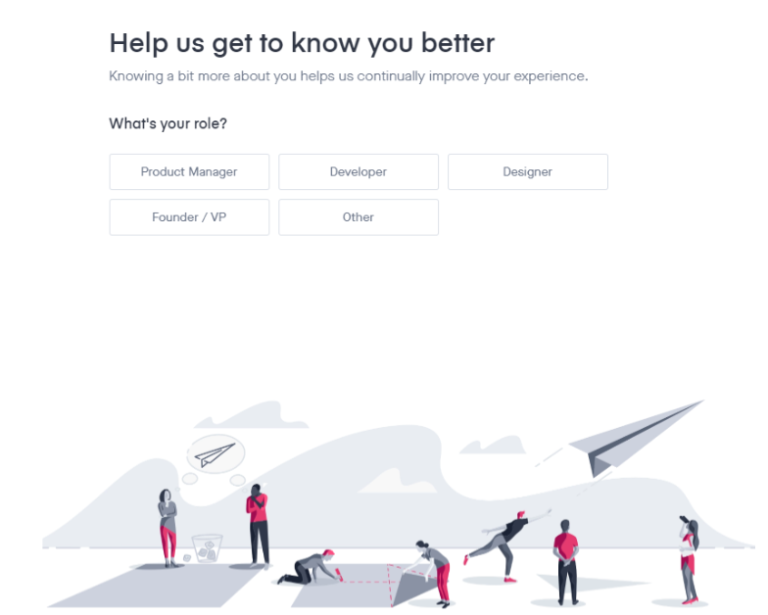

Your projects folder can be empty now. Request sharing of mockups from Mentor

